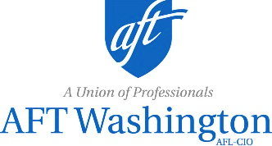
Local 8045R Annual Meeting
May 21, 2021
10 - 11:30 AM
To be held virtually

TENTATIVE Agenda
- Meeting Called to Order
- Introductions
- Quorum
- Approval of Agenda
- Appointments
  - Minutes Review Committee
- 2020 Minutes
- Resolutions/Bylaws Amendments
- Reports
  - President
  - Treasurer
  - Other Officers
  - Nominations & Elections Committee
- New Business
  - Retiree Chapter Officer Elections
    - Call for nominations
    - Candidate introductions
    - Vote
    - Adopt slate
- Social Security Works Report
- The Next Two Years
  - Open discussion by all on what members would like to see such as relevant workshops, speakers, handouts, organizing, local contact for future Retirees Committee formation.
- Adjournment

