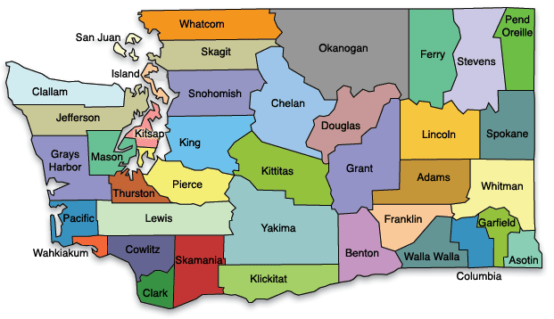
Snohomish Cohort: Snohomish County

North King Cohort: North King County
South King Cohort: South King County

Pierce Cohort: Pierce County

South Cohort: Thurston, Lewis, Mason, and Grays Harbor Counties

North Cohort: Whatcom and Skagit Counties

